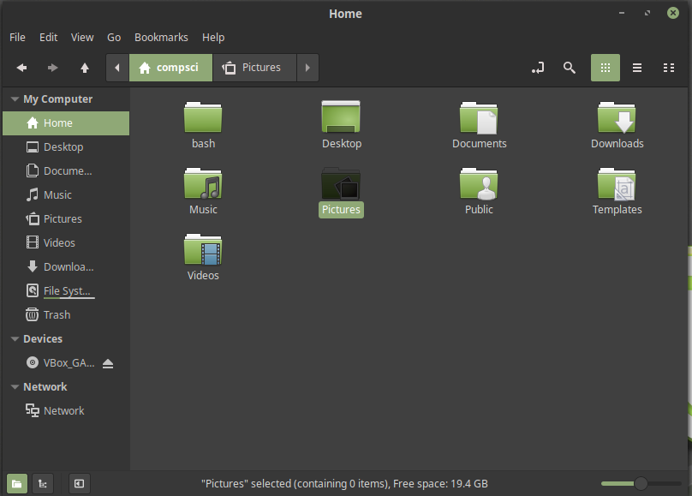
To begin learning bash I created a folder to hold all my programs
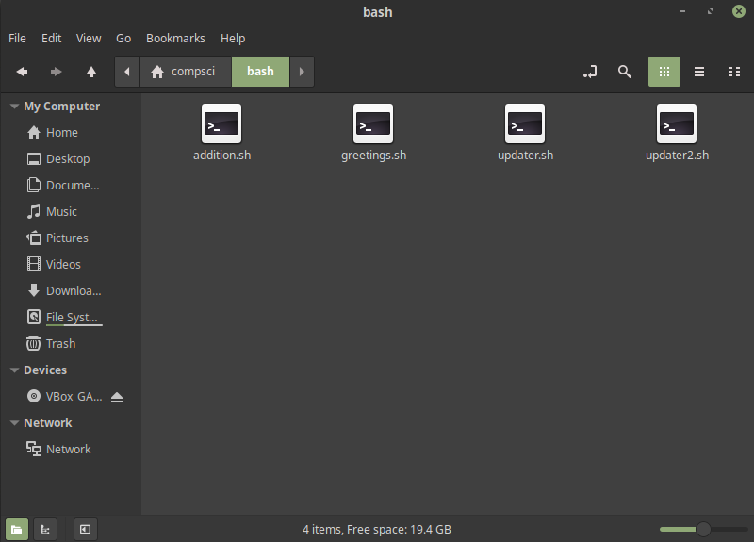
Inside this folder are my .sh program files
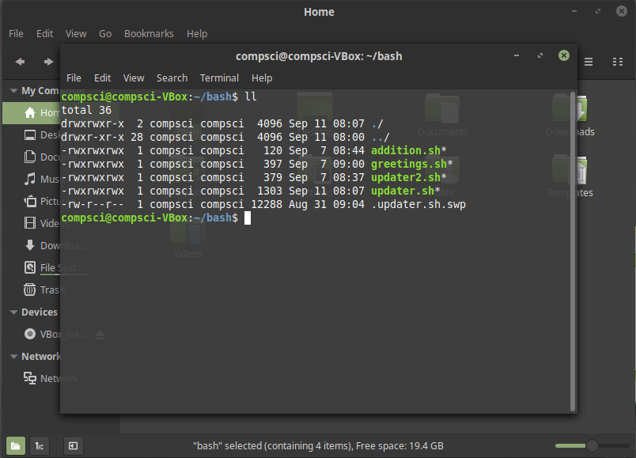
in order to run my programs I needed to give myself permission using the command sudo chmod 777 ..
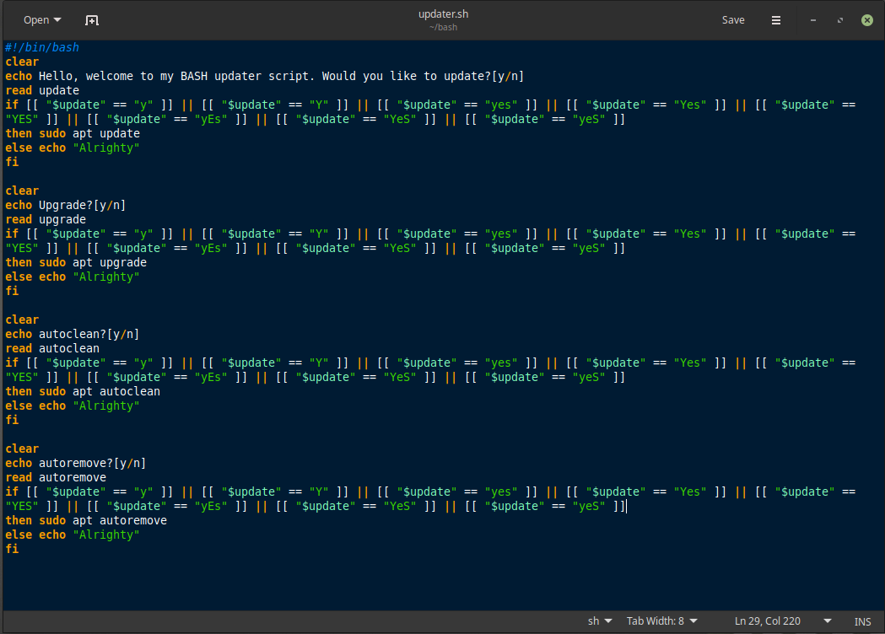
to edit my programs I downloaded and used gedit
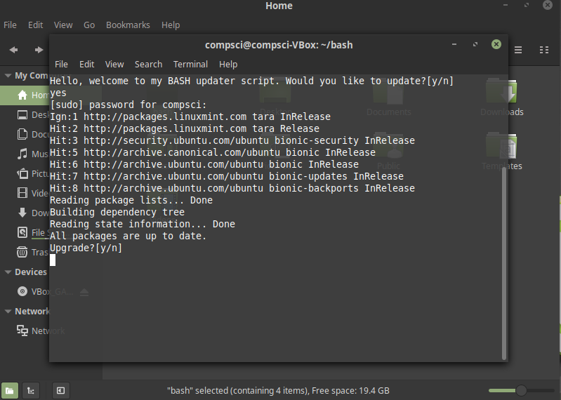
./program_name

